About the Festival
Celebrate this one-of-a-kind festival for
its 50th Anniversary. The Folklorama experience will be unforgettable and includes a delicious and authentic cultural progressive meal throughout the night.
You will be treated to VIP entry and reserved seating. In addition, each experience (Pavilion) will captivate you
and will offer a variety of entertainment; from dance, cuisine, art, language, stories, music, cultural displays, and/or shopping.

Night one (August 12):
Pavilion of Scotland: Cultural appetizer
and cultural alcoholic beverage
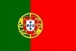
Casa do Minho Portuguese Pavilion: Cultural meal and domestic alcoholic
beverage
Polish Pavilion: Cultural dessert and
non-alcoholic beverage

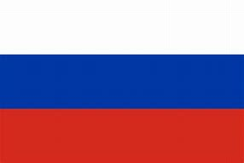
Night two (August 13):
Russian Pavilion: Cultural appetizer and
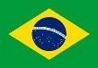
cultural alcoholic beverage
Brazilian Pavilion: Cultural meal and
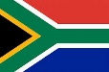
domestic alcoholic beverage
Africa/Caribbean Pavilion: Cultural
dessert and non-alcoholic beverage
Itinerary:
- Day 1 – We depart Parkers Prairie at 7 am (indicate on the Registration if you wish a different location). We will enter Canada at the Pembina/Emerson Border Crossing and then continue to our hotel to freshen up for dinner at the lovely Promenade Café and Wine and a guided tour of the Canadian Museum for Human Rights.
- Day 2 – We start with breakfast and then meet our step-on guide for a city tour of Winnipeg. After a morning of enjoying the magnificent scenery and history of Winnipeg, we will stop off for an included lunch at Assiniboine Park Café. After lunch we will have a guided tour of Journey to Churchill at the Assiniboine Zoo. The exhibit is home to polar bears, muskoxen, Arctic fox and other northern species in naturalistic landscapes and animal viewing areas. After the zoo, we will return to the hotel to freshen up before our evening festivities at Folklorama (see night one at the left).
- Day 3 – After breakfast our first stop will be a guided tour of the Royal Canadian Mint, every single Canadian circulation coin is produced here—literally billions each year. Next, we visit the Forks Market to enjoy some free time and shopping. Lunch will be on your own at the Market. Our afternoon will be spent at the Manitoba Museum where we will have a guided tour of the galleries that tell the story of Manitoba. The Museum features an impressive display of Hudson’s Bay
Company artifacts which reveal the story of the oldest commercial enterprise still in existence today. After the Museum, we will return to the hotel to prepare
for another great evening of fun, food, and festivities at Folklorama (see night two at the far left)!
- Day 4 – After breakfast we will depart visit Fort Whyte Alive; a nature centre that provides programming in natural settings for outdoor recreation and learning. Our tour will focus on the time when bison roamed the prairie, and people’s connection to the natural world was a matter of survival. This stop wouldn’t be complete without a visit to Pioneer Sod House and the Bison Viewing Mound. After our tour we will depart Winnipeg with wonderful memories!
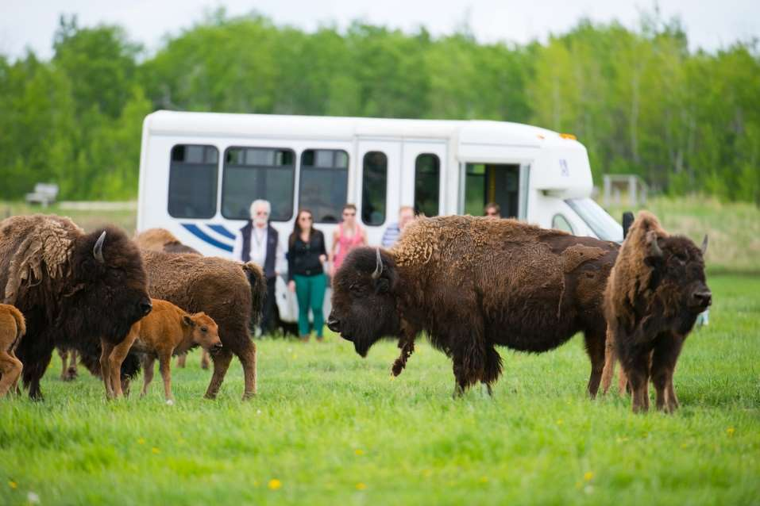

Winnipeg, Manitoba:
Located right in the heart of North America, Winnipeg is the hip, happening capital of Manitoba. The city is renowned for its world-class attractions, historic sites, and lively cultural gatherings.
Hotel accommodations:
Canad Inns Club Regent:
Winnipeg’s only hotel connected to a casino complex. Amenities include fitness center; numerous dining options; and an in-room refrigerator, coffee maker, hair dryer, iron/ironing board, and high-speed WiFi.

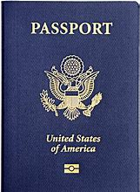
Border Entry Requirements:
The United States
requires all travelers to and
from Canada to present a
passport or equivalent travel
document, such as a NeXUS card to enter that country and to re-enter the United States when returning home. When traveling by land, a passport is not required, but is strongly recommended. Alternatively you will need other documentation that shows proof of American citizenship such as a birth certificate, a certificate of citizenship or naturalization, or a Certificate of Indian Status; plus a photo ID. Remember will need to comply with stricter U.S. entry requirements to return to the U.S.
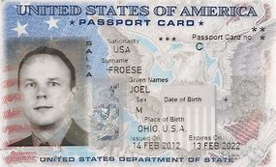
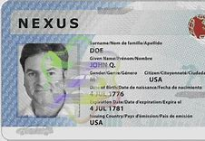

Visit www.travel.state.gov for the most up-to-date information on passport requirements.
Package includes:
- 3 nights lodging with luggage handling
- 3 breakfasts (at hotel), 1 lunch, 3 dinners (2 progressive dinners at Folklorama Festival)
- Guided tours and applicable admission for locations listed in itinerary

Price per person:
Quad occ: $605* | Triple occ: $630*
Double occ: $685* | Single occ: $845*

To sign up and reserve your spots, send the registration portion and deposit of $200 (per person); balance is due by Aug 1.

All major credit cards are accepted; if you choose to pay via credit card a 5% convenience fee will be added to your transaction. To pay by credit card, please call our toll free number at 1-877-250-8857.

*In the event that Hart Travel needs to cancel this
trip, all payments will be refunded in full.

Contact:
Hart Travel, LLC
1-877-250-8857 (toll free)
218-338-4278
jillharttravel@gmail.com

Mailing address: 221 N McCornell Ave Parkers Prairie, MN 56361
Physical address: 416 N Otter Ave
Parkers Prairie, MN 56361

Presents:
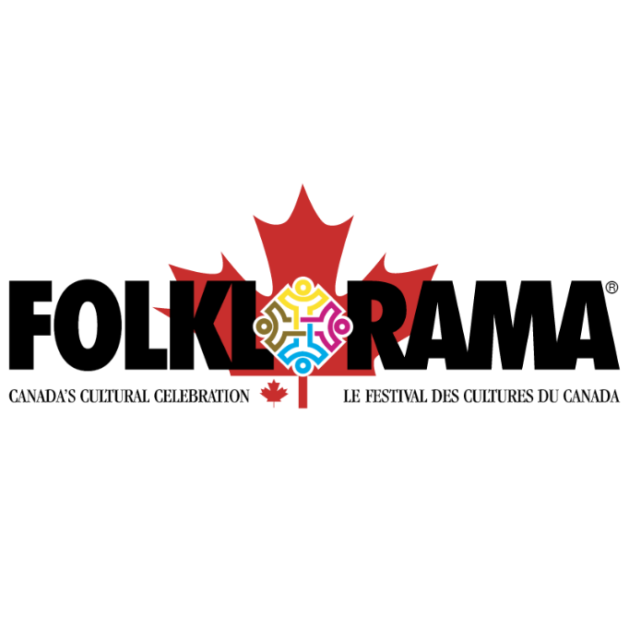
Winnipeg, Canada
and

on
August 11-14, 2019

Celebrate life and culture with world-class entertainment, delicious authentic food, and beautiful cultural displays. This is the largest and longest-running multicultural festival of its kind in the world.

This festival is held annually during the first two weeks of August in Winnipeg, Manitoba, Canada. Join us and explore one of the most vibrant arts and culture scenes found in the heart of the continent.

www.harttravel.net

